Homework 1, 100pt: GUI Design Using Java GUI
CS421, Fall 2018, Due 11:59 pm, Sep 10

Write a GUI based desktop Java Program that emulates a course schedule lookup. You can refer to the SVSU cardinal direct page. To make the problem simple, we assume the course lookup is only for the current CSIS department for fall 2018. The courses offered from the CSIS department have course prefixes starting with CS, CIS, and CSIS.
The following shows the main screen.
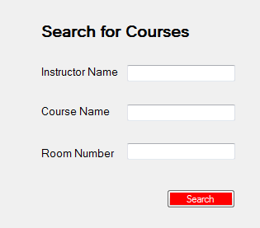

For CS421, you will have the following search result.
Course | Title | Instructor | Room Number | Time
CS421 | Object Oriented Design & Dev | I. Cho | SE117 | TR 12:30PM – 2:20PM

The instructor name is searched by last name. For last name Cho, the search result will be like
Course | Title | Instructor | Room Number | Time
CS146 | Visual Basic .NET Programming | I. Cho | SE145 | M 7:00PM – 10:00PM
CS421 | Object Oriented Design & Dev | I. Cho | SE117 | TR 12:30PM – 2:20PM
CIS386 | Database Management Systems | I. Cho | SW143 | MW 2:30PM – 4:20PM

Note that the main search screen and the result page is for a reference. You can come up with your own GUI layout if it accepts the search criteria and shows the result information (course number, title, instructor, room number, and time), and the exact GUI is up to you.
Show the search results from the following search criteria:
- By course: CS421
- By instructor: Cho
- By instructor: James
- By room number: SE145
- (Bonus: 5 pts) By course - this is for partial string search
  - CS
  - CIS
  - CSIS
- (Bonus: 5 pts) By title – this is for partial string search
  - programming
  - system
  - computer
Note that all search is case insensitive.
You need to grab all the class schedule information of the CSIS department from the cardinal direct page and read them into your program. Do not use database and database query for the search.

You can use GUI builder applications supported in IDEs like NetBeans or Visual Studio to build GUIs. However, you are encouraged to not to use them. You can use Java Swing or JavaFX classes (JavaFX is preferred) or Visual Studio (if you use C#, not Visual Basic) to make your own layout and GUI components.

What to submit
- Hard copy:
  - Sample output that shows the working of your program
- Electronic copy:
  - All source code properly commented with Javadoc, zipped to a zip file: hw1-lastname.zip
  - A jar file which should work when double clicked. (Verify the working of the jar file by running it from different machines.)
  - Input file (if any)
Specify the version of JDK you used for your program in the program comment section.
To get a full point, be sure to document properly (for classes, methods, …) using Javadoc format and properly layout your code. 20% of the grading will be for documentation and code layout.

